**Home Automation**

**using**

**Augmented Reality**

(**System manual)**

**System Requirements**

**Minimum technical specifications:**

* Platform: Android phone
* Operating system: Android
* Android version: Android 5.1.1 "Lollipop"
* Minimum Ram: 512 rams

**Android phone permissions:**

Note: Please allow all of the following permissions needed.

* Camera
* Storage
* Bluetooth

**Installing**

1. First, find the APK in your phone folder.
2. Before you can install it on your phone you will need to make sure that third-party apps are allowed on your device.
3. Go to **Menu > Settings > Security >** and check **Unknown Sources** to allow your phone to install apps from sources other than the Google Play Store.

**Home Page**

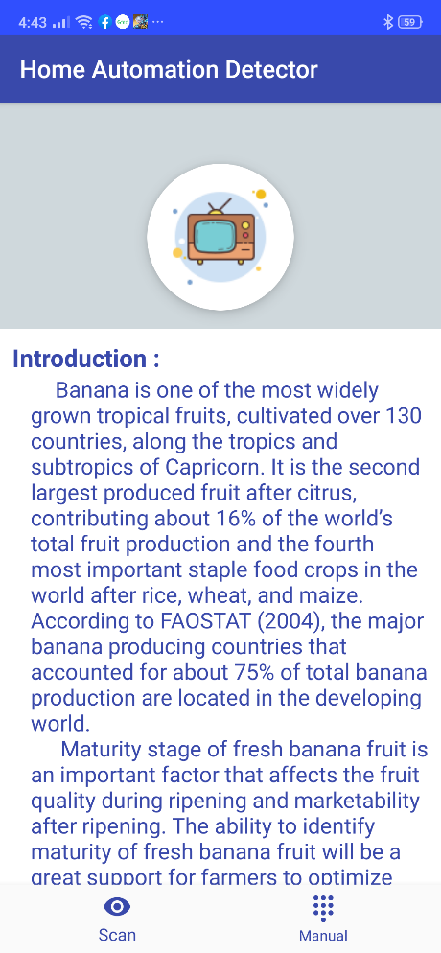

|  |  |  |
| --- | --- | --- |
| **Control** | **Control Name** | **Description** |
|  | Scan button navigation | To show the scan page. |
|  | Manual button navigation | To show the manual page. |

**Scan Page**

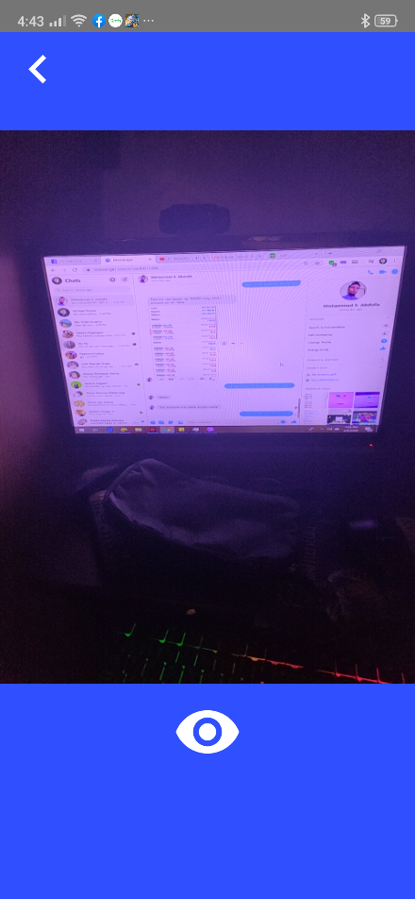 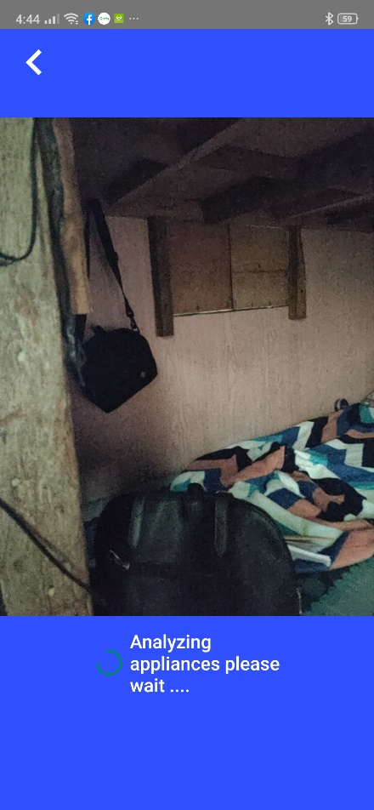 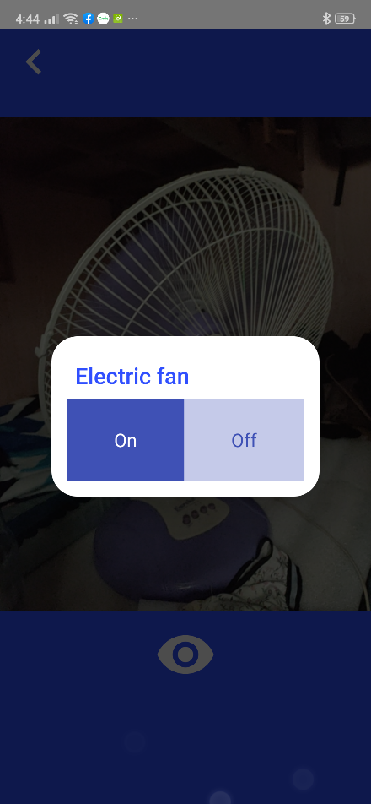

|  |  |  |
| --- | --- | --- |
| **Control** | **Control Name** | **Description** |
|  | Scan button | To start the validation for every frame. |
|  | Back button | To back the previous page. |
|  | Video area | Where the video camera show. |
|  | Turn on and off option button | To turn on and off of the specific appliances. |
|  | Scan loading indicator | Shows the analyzing appliances indicator. |

**Manual Page**

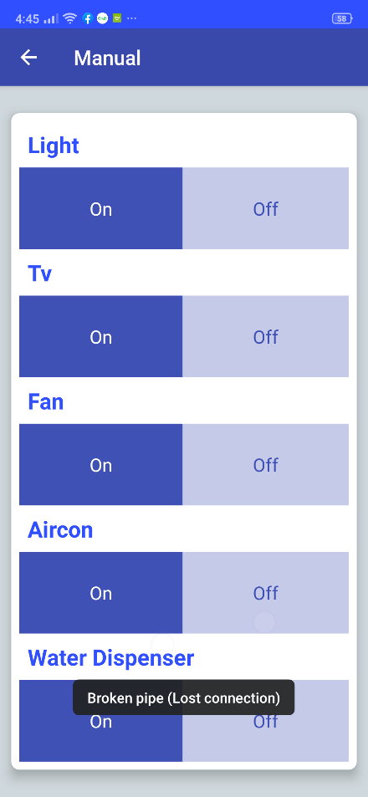

|  |  |  |
| --- | --- | --- |
| **Control** | **Control Name** | **Description** |
|  | Turn on and off option button | To turn on and off of the specific appliances. |
|  | Lost connection indicator | Shows the Lost connection indicator. It means the Bluetooth and android lost their connection. |
|  | Back button | To back the previous page. |